|  |
| --- |
| *We-Care Patient Management System* |
| Requirements Document |
| |  |  | | --- | --- | | Student No | Full Name | | 2009062 | Dinuk Caldera | | 2009084 | Pasindu Jayawardene | | 2009083 | Nithya Ranadeerage | | 2009067 | Randula Wijesinghe | |

Contents

1 Introduction 3

1.1 The purpose of the Requirement Documentation 3

1.2 Product Scope 4

1.3 Main objective 4

1.4 Definition acronyms and abbreviation 5

1.5 References 5

1.6 Overview of the remains of the document 6

2 General 7

2.1 Product Perspective 7

2.2 Product Functions 9

2.3 User Characteristics 10

3 Specific Requirement covering 11

3.1 Functional Requirements 11

3.2 Non-Functional Requirements. 13

3.3 Interface Requirements 14

3.4 Extended Interface 18

3.5 Services and Functions 21

3.6 Design Constraints 21

3.7 Logical database requirements 22

3.8 Quality characteristics 24

# Introduction

## The purpose of the Requirement Documentation

The requirements documentation is mainly focused on an essential description about the patient data base system. Requirement documentation will not contain any information about the implementation stages or the steps of the system implementation. The main purpose of creating patient database system is to increase efficiency and to improve the health care sector of Sri Lanka which is currently running as a manual based system of storing information about the patient details which will leads into various constrains in health care sector. Such constrains are, storing patient information in a manual hand written way will require massive amount of space allocation and also cannot be accessed by hospitals around country. The end users of the patient database system will be the hospital/clinic/laboratory staff. The system can be accessed by any hospital in the country to cross reference patient details.

The report mainly elaborates on two key factors which are being listed below:-

1. What the database system must do
2. Additional features of the patient database system apart from the manual based system.

“General Description” section of the report provides the system’s multi user categories which define the main users of the patient database system along with the assumptions and dependencies which came across in the project during the designing. Furthermore the “Specific Requirement Covering” section of the report elaborates features of the patient database. Requirements of the system are being broken down mainly into three components, which are listed below.

1. Functional Requirements

2. Non functional Requirements

3. Interface Requirements

The interfaces of database will indicate simplicity of interacting with system which also will clearly visualize many categories and sub categories of the system.

## Product Scope

The system that will be built, to manage the patient information system will be developed incrementally to ensure that the system will enhances and help out the client from the system which will be the hospital staff. The major focus of the database system is to develop a system which will enhance health care system of the country and to create a more accurate and efficient data elicitation. The system can carry out the activities which are listed below :

1. Monitor Patients Health History
2. Update and view medical history of a patient.
3. Recognize Blood Donors
4. Data Redundancy and Reduce Data Repetition
5. Hereditary Disease Detection
6. Notification/Alerts for the patient
7. Patient details and functionality of the system can be done from any hospital in the country.

The patient database system will use existing sources of information within the hospitals and will seek to find new sources when particular patients register with system. The team will seek to use the existing manual based steps with additional features to create the patient database system to suit for each hospital. This will ensure that less labor force will be used in entering details about the patient, less human errors with involvement of the system, cost constraints will be less **.**

## Main objective

1. Project is to improve efficiency of the health care sector of Sri Lanka.
2. Reduce cost constraints
3. Labor Force is less.
4. Reduce the Wastage of Hospital Resources
5. Improve health care of the patient.

## Definition acronyms and abbreviation

***Definition:*** *A word formed by using the initials of a phrase or other groups of words.*

*An acronym is often considered to be a type of abbreviation. Generally, if an abbreviation is pronounced as a word rather than as the letters individually, it is considered an acronym. Often the distinction isn't always made between acronyms and abbreviations, especially when the abbreviation is more widely known than what it stands for, such as "PVC" (polyvinyl chloride) and "ATM" (automated teller machine).*

***(Source -*** [***http://spanish.about.com/od/historyofspanish/g/acronym_gl.htm***](http://spanish.about.com/od/historyofspanish/g/acronym_gl.htm)***)***

|  |  |
| --- | --- |
| **Term** | **Definition / Unabbreviated term** |
| **Admin** | Administrator; the end-user of the software |
| **Hospital Staff** | the end-user of the software |
| **GUI** | Graphical User Interface |
| **CT Scan** | Computed tomography Scan |
| **MRI Scan** | Magnetic resonance imaging Scan |
| **Biopsy Report** | The removal and examination of a sample of tissue from a living body for diagnostic purposes. |
| **DB - Database** | an organized body of related information |

## References

1. http://www.niwotridge.com/Essays/WhatisSystemArchitecture.htm
2. <http://theboka.wordpress.com/2007/12/22/software-requirements-document-purpose/>

## Overview of the remains of the document

The particular section of the report elaborates, giving the reader, a brief sneak preview of the project which is being developed for the improvement of the Sri Lanka health Care sector which will be based on storing information on patients in a database. The rest of the documentation will indicate the following;

**Second phase** of the documentation will contain basic understanding of the patient database. This particular section will elaborate on the users who will be interacting with the database. The constrains of the project and also the assumptions and the dependences are included.

**Third phase** of the documentation will give brief description about the requirements of the patient database. Its second part covers varieties of topics which are listed below.

1. Functional requirements
2. Non functional requirements
3. Hardware and software requirements

This will provide the reader an understanding and knowledge about what the database is being implemented into and the specific purpose of the database.

**Fourth phase** will contain the Appendixes and the final phase will contain the Index

# General

## Product Perspective

The patient information system will replace the manual based system on storing information about the patient which is time consuming, lack space allocation for files to store; excessive of labor force is being used. The system will be used by the hospital staff which will be the end users of the database. There are four main actors interacting with the system :-

1. Doctor
2. Clerk
3. Administrator
4. Pathologies

**The administrator** will be the admin for the system for updating or adding new doctors for the system providing a user name and password to gain access for the database.

**The clerk works under the doctor** where he/she hasas the authority to carry out this particular task in the systems which are listed below: -

1. Add new patient
2. Update patient records
3. Update diagnoses given to the patient
4. View the database
5. Add diagnoses given to the patient
6. Send notifications to the patients

**The Lab pathologists/staff** has the authority to carry out tasks such as

1. Send notification to the patients. Ex – notification about CT scan schedule for the patient
2. View patients diagnostic details
3. Add lab results

Adding patient details

Patient Database

Updating exists patient records

Retrieving date

Hereditary Diseases detection

Patient Reminders

Blood Donor

Assignment

Pandemics infection diseases warnings

Add Lab Results

View patient Details

## Product Functions

This part of the report elaborates on the requirements which are related to the specific functions of the patient database system. The table below indicates the function in one column and the 2nd column explains about the description of the each and individual function.

|  |  |
| --- | --- |
| **Functions** | **Descriptions** |
| 1. Add new Patients | The system will be enabling to add new patient record to the system. |
| 1. Add new Doctor | The system will be enabling to add new doctors to the system to gain access for the patient DB. The doctor will be assigned with a user name and password to gain access to the DB |
| 1. View Details of DB | The user which can view the patient details can view the details of the patients. |
| 1. Send notifications to the patient | 1. Sending patients appointment by the lab pathologies. 2. Notifying patients on diseases within area. |
| 1. Add diagnoses | Add various diagnoses to the patient who is registered to the database. |
| 1. Update diagnoses | Update diagnoses to the patient who is registered to the database. |
| 1. Add lab results | Pathologies department can add lab result of the individual patient. |
| 1. Blood donate DB | Blood type will be saved when registration of the patient. If the patient tangible to donate blood, the patient will be saved In database saying enable to provide blood. |

## User Characteristics

**Admin**

The admin of the system has full accessibility to the database. He has full privilege to edit the system according to the relevant data sources.

**Admin**

**Doctors/ Clark**

**Access**

**Lab Access**

Access, modify, and change the patient and doctor details.

Adding patient info retrieve patient info

Retrieve patient info

**Doctors Access:**

While Doctor retrieves all relevant details of the patient clerk will enter them to the system. Clerk will be handling all data under the supervision of the doctor. Doctor has the privilege to access all patient details and edit them accordingly.

**Lab Access:**

All the information of the patient regarding to the lab can be accessed by the laboratory staff. They have the privilege to edit and retrieve patient data according to the relevant needs.

# Specific Requirement covering

## Functional Requirements

**1 .Alert about hereditary diseases**

First patient will be registered to the system with the basic information such as Name, Age, Presenting complaint etc. Once we get the patient’s mother’s and father’s name that information will be we cross referenced with our system and if parents have a disease that follows through genes from generation to generation then the system will simply display an alert saying that this patient’s mother/father had this disease and that information will be automatically added to patient’s profile.

**2. Set appointments for CT scan, MRI scan etc.**

In the current health care system if a patient has to be scanned by a CT scanner or an MRI scanner then the patient has to wait a long time and get the appointment. But using this system when doctor orders a scanning then an alert will be passed to the client application in the Laboratory and then the Lab staff can find a suitable time slot for the particular patient and assign the appointment. After assigning the appointment LAB staff can inform the patient via SMS using this system.

**3. Ongoing Investigation reports**

When a patient registers to our system and if the doctor needs an investigative report such as TSH report or Biopsy report etc then doctor has to make a request for a particular report using this system. Then the relevant party will be alerted and the report will be pending. Reports like these can take up to three days to be finalized and delivered.

And one of the fallacies we could see in the current health care system was when a particular doctor has made a request for a report such as these and another doctor makes a request for the same report not knowing that the same report for the same patient is pending. Doing so increases the cost of the patient’s bill and that particular patient has to pay a useless amount of money because of the fallacy of the health care system.

But when using our system when a doctor makes a request that request will be added to the profile and when another doctor tries to request the same report an alert will be displaying that this particular for the patient is pending.

**4. Area Announcements for Pandemic/Infectious Diseases**

Diseases like dengue, Malaria are one of the major spreading diseases in Sri Lanka. The current health care system has failed to inform the relevant people in the areas that are most vulnerable to these diseases. But using our system we have overcome that problem. When patients register in our system we store their addresses and mobile phone numbers as basic contact details. So when we need to make a general announcement to the public saying that a particular area is vulnerable to this particular disease we can inform the people in that area through SMS.

And after using this system for 2-3 years we can make predictions about the wide spreading diseases saying that this particular area has reported the most number of patients for this particular disease so the this much of drugs and vaccinations should be allocated to that area. So then in the following years medical staff will be able to successfully control the disease. Once the relevant drugs and vaccination have arrived we can inform people that are registered in the system via SMS to come and get the vaccination and drugs.

**5 .Inform Blood Donators**

When we get the details about the patient the blood type is one of the major requirements we have to input to the system. And during the time we get the details of the patient doctor has to tick a check box that answers whether patient is eligible to donate blood. Eligible means that the patient is willingly to donate blood and that patient has no diseases such as HIV. And once that hospital needs a particular blood type so that medical staff can inform the people who are close to the hospital via SMS and ask them to donate blood. That way we can react more efficiently and quickly in an emergency situation.

## Non-Functional Requirements.

**1. Security Issues –**

The system we are developing requires a large database filled with information about the patients. So we have to handle with information in a transparent way and we have to make sure that no one outside the relevant staff can access the database. The information on the database is very sensitive and if anything gets misplaced or gets changed that may cause death for a patient. So we when developing the system we will ensure that only the relevant people will get access to the system and those people will get an username and a password to access the system

**2 .Online traffic –**

What we are dealing with here is a system that records details about the patients all around the country. So at a particular moment a large number of users(medical staff) may be logged in to the system and may exchange data within the hospital chain. So the servers may gets crashed or get stuck. So we might have to develop a solution for this problem as well.

**3. Performance Requirements**

When dealing with a large database it might take some time to retrieve the data of a past patient and to function correctly. So that may be an issue when dealing with sensitive information. So we have to come up with a solution for that too.

**4 .Operating availability 24/7**

We have to get a separate server to store all these contents in the database as we cannot store this sensitive data on a shared server and we have to buy an internal server that runs 24/7.

## Interface Requirements

**1. Details about the patient Filled by Doctor/Clerk**

|  |  |  |
| --- | --- | --- |
| **Name Of the filed** | **Type of the Parameter** | **Maximum No of characters** |
| 1. Patient No | NUMBER | 10 |
| 1. Identity Card Number | VARCHAR | 10 |
| 1. Full Name | VARCHAR2 | 60 |
| 1. Name with Initials | VARCHAR2 | 30 |
| 1. Age | NUMBER | 3 |
| 1. Birthday | DATE | 8 |
| 1. Address | VARCHAR2 | 150 |
| 1. Mobile Phone Number | NUMBER | 10 |
| 1. Land phone Number | NUMBER | 10 |
| 1. Blood Group | VARCHAR2 | 2 |
| 1. Presenting complaint | VARCHAR2 | 150 |
| 1. History of the Presenting complaint | VARCHAR2 | 150 |
| 1. Hereditary Diseases | VARCHAR2 | 100 |
| 1. Systematic Review | VARCHAR2 | 100 |
| 1. Past Medical History | VARCHAR2 | 300 |
| 1. Past Surgical History | VARCHAR2 | 300 |
| 1. Ongoing Drug History | VARCHAR2 | 100 |
| 1. Family History | VARCHAR2 | 150 |
| 1. Allergy History | VARCHAR2 | 150 |
| 1. Social History | VARCHAR2 | 150 |

**1 – Patient No –**

This is the primary key of the patient details database and will be use to identify each patient uniquely.

**2 – Identity Card Number –**

This will be stored to identify the unconscious patient and treat with relevant treatments.

**3 to 9 - Basic Details about the patient –**

Here the doctor will be collecting all the basic details like name, age etc about the patient to get to know him/her.

**10 – Blood Group –**

Blood group will be used for two major functionalities of the system. First one will be when patient needs blood by viewing his/her profile we can easily identify the blood type of the patient. This comes very important when patient meets with an accident and if he/she is unconscious we don’t have to bother running through all the test to identify the blood type. We can simply log in to the system and view the profile and supply the relevant blood type.

The next thing is if he is eligible to donate blood we can store his data as a blood donator and if in case of an emergency and if the hospital needs that blood type we can contact him and ask him to donate blood.

**11 – Presenting Complaint –**

This field will be used to identify the illness using the symptoms the patient shows.

**12 – History of the presenting complaint –**

Here the doctor will save all the information about the history of the current illnesses. This will be important to the pathologist to identify the illness more effectively if a blood test has to be carried out.

**13 – Hereditary Diseases –**

This field will contain two containers.

First one will be the hereditary diseases that came through his/her parents’ genes. This will be automatically filled with the data currently we have in our system about the patients’ parents.

And the other one will be the diseases that first started in this particular patient and can be inherited to his/her children.

**14 – Systematic Review –**

There are four major systems and four sub systems in our body. The patient will be attended due to one or more problems in these systems. But doctor will carry out a whole review for these eight systems just to get a clear idea that there are no other problems with the patient before treatments begin.

**15 – Past Medical History –**

This field will be filled by the doctor the first time that patient registers to the system and after that this field will be automatically filled with the past entries that are stored in the system. After finishing the undergoing treatments those will be stored in the past medical history field.

**16 – Past Surgical History –**

field is also one time entering field as when the patient under goes a surgery that data will be stored and that data will be retrieved later for future references. This field will contain entries such as cardiac condition and reports such as ultra sound report, Echo Cardiograms etc. Once this field is filled doctor can retrieve this data and continue with treatments.

**17 – Ongoing Drugs –**

This field will contain information about the drugs that patient takes currently. So that the doctor can assign drugs effectively. And so that doctor can avoid assigning drugs that are reactive with ongoing drugs.

**18 – Family History –**

This field is to be filled when the patient’s parents are currently not registered in our system. Using this information doctor can identify the illnesses and hereditary diseases before treatments begin.

**19 – Allergy History –**

This field will be filled with the allergies that patient has before writing a prescription. This field can be used for future references as well.

**20 – Social History –**

This field has to be filled with social activities like Smoking, Alcohol usage and the salary etc.

**2. Details About patient filled by Laboratory Staff**

|  |  |  |
| --- | --- | --- |
| **Name Of the field** | **Type of the parameter** | **Maximum No of characters** |
| 1. Report No | NUMBER | 10 |
| 1. Details | VARCHAR2 | 150 |

**1 – Report No –**

This is the unique No that given to every report so that doctors can further investigate about the report in the future.

**2 – Details –**

This will be filled with a comprehensive details about the report the decision made by the investigation.

## Extended Interface

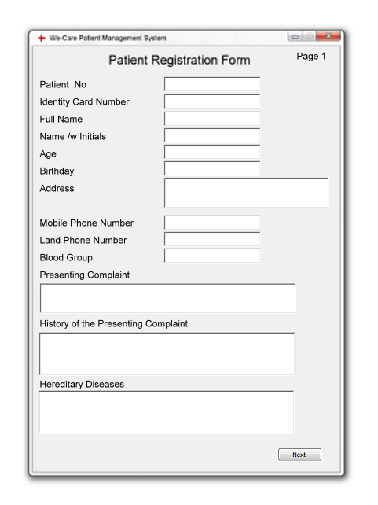

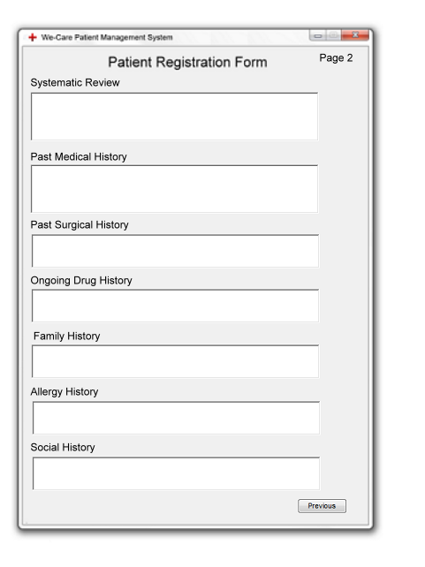

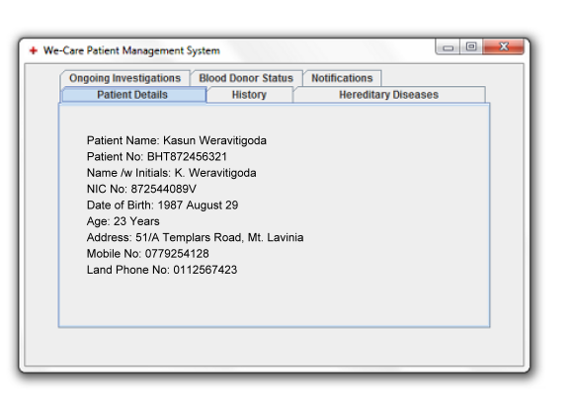

## Services and Functions

This is an automated patient management database system that enables doctors and lab staff to retrieve patient’s details and history of each patient easily on time. This provides alert system about hereditary diseases / help to Set appointments for CT scan, MRI scan etc./Ongoing Investigation reports / Area Announcement for Pandemic/Infectious Diseases /Inform Blood Donators.

So doctors able to see patients details and history on time and doctors also can successfully deal in easy way of retrieving data even from a large crowd of patients effectively The output of the system consist of areas that enter patient details and techniques to manage and edit patients details according to relevant data.

**Requirements**

* The data will store in a database which user can input data through the GUI application we create and handle all possible areas that doctor and lab staff needs.
* User have all privileges to edit records according to the relevant situations

## Design Constraints

Still we could not be able to determine any design constrains which we have to identify data sources accurately. Mainly it focus on connecting the database to the application through GUI which we create and enabling to retrieve data according to needs of the user of the system. This help doctors to make decisions immediately by even checking the history of the patient from a large patient database other than searching manually.

## Logical database requirements

System should be able to fetch information about the patient, Doctor and Lab report. The database would contain the following tables with the following fields:

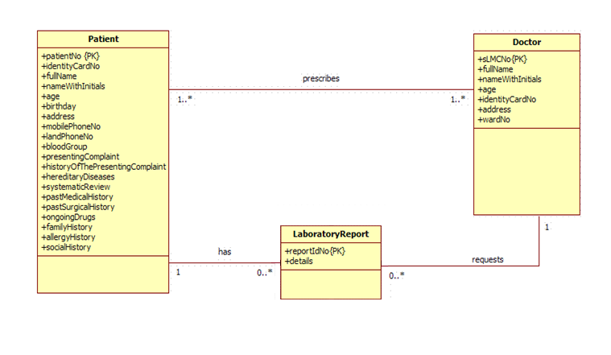

**Use Case Diagram**

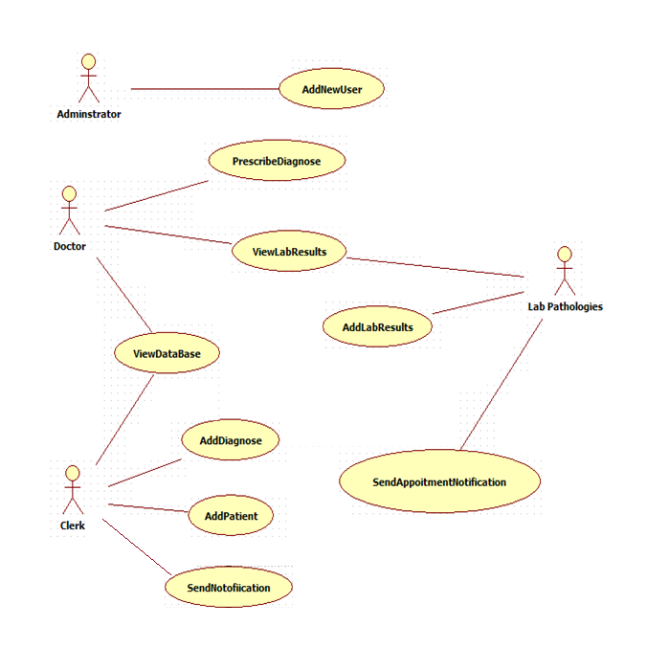

## Quality characteristics

Reliability

The system will be connected to a database which would be further backed up automatically by the system itself in a different secure location ensuring that at all times the details of patient’s medical history etc. will be available for doctors or any other relevant actors to access. The system will have error handling commands to ensure that no error will be faced by the system or the users as the data and medical history details are sensitive and needs to be precise.

Maintainability

The maintenance of the software will be simple as the interfaces are user friendly and the main system data and information will be backed up. Also, the coding and database linkages used on the software are such to prevent the system for crashing easily.Further customizations and upgrades can be incorporated as necessary.

Security

As for security concerns the doctor actor will be the only person to have full/all access to the system and its databases through the login, whereas the other users could login to the system with the given individual username and password to enter details, send reminders to patients and update report results.